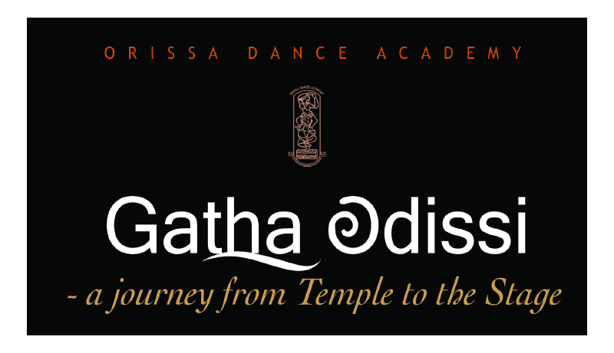

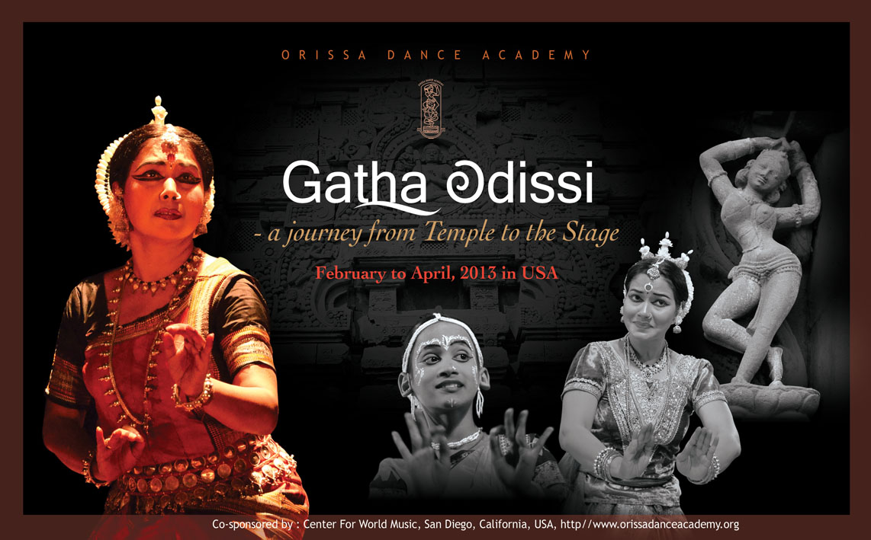

GATHA ODISSI – A journey from the temple to the stage
History is not scripted; it gets created over the ages. It transforms itself according to the tides of life and times. After the sunrise, comes the dark hour of the sunset. The rhythmic foot falls of Odissi dance continue to reverberate in the Temple of Jagannatha through the corridors of history.
MANGALACHARANA :
JAGANNATHA ASTAKAM
This is an invocation to Lord Jagannatha who holds the divine flute in his hand , a peacock feather in his crown and a yellow silk around his waist. He is the one who bestows loving glances upon his companion and who is famous for his great ‘Leela’ in Vrindabana. May my Swami, Lord Jagannatha grace himself to my sight.
O Deva! Please do quickly deliver me from this futile worldly existence. O Lord of Yadus! Please purge me of my unlimited sins. You always offer refuge to the fallen and the unsheltered; O’ my Swami, Lord Jagannatha, offer your grace to my sight.
PALLAVI :
Raga- Khamaj & Taal- Ek tali
Pallavi means elaboration. It is an item of pure dance with movements of lyrical grace. It is based on the melody of a soft and tilting raga. Beautiful dance passages run parallel with rhythmic syllables sung musically.
ABHINAYA :
RAMAYANA - NAVARASA
Rasa is the basis of art. The goal of the art is to evoke rasa. Through movements, music and acting the artist creates the rasa and conveys it to the audience in order to help create the mood. There are nine rasa(s), we explore each using various episodes from Valmiki’s Ramayana.
In sringara rasa or love, hand gestures and facial expressions are used to show Rama and Sita sharing in the joys of being together, even the nature rejoices.
As Rama breaks Shiva’s bow to win the hand of Sita, he becomes the embodiment of veera rasa or chivalry.
When the demoness Shooparnaka is sent back and forth between Lakshmana and Rama, hasya rasa or humor and laughter, is evoked.
The whole forest of Panchavati is filled with fearful sounds as Sita is abducted by Ravana. The mood is one of bhayaanaka or fear.
When Rama sees his friend and devotee, Jatayu, dying in his hands, he is full of karuna rasa or compassion.
Rama is full of wonderment (adbhuta rasa) as the army of monkeys builds the bridge the Setu Bandha, the bridge that connects to Ravan’s Lanka.
Seeing the battlefield strewn with dead and maimed bodies makes one full of bibhatsa rasa or disgust.
Rama confronts Ravana in the battlefield exhibiting Raudra rasa or wrath.

INTERMISSION
KRISHNA SARANAM
Krishna’s messages for the world, an interpretation in Dance.
Krishna is beloved of all who knew him when he chose to incarnate as a mortal; Krishna, beloved of all who worship him as God; Krishna, who inspires a myriad expressions of love and devotion; a god, whom devotees relate as an equal, as someone most dear.
His actions were very human - innocent, playful, willful, contradictory and at times seemingly underhand and manipulative, reflections of which we see within each one of us. And yet those actions had a deep meaning, often several layers of meanings.
What lessons do these acts hold out for each of us and what values do those so subtly uphold? The seven episodes of this presentation are snapshots from Krishna’s life that portray his values.
Episode 1
Krishna enacted his Leela to bring order to a chaotic world. The birth of Krishna.
Episode 2
Kaliya Dalana and Giri Govardhana are two incidents where Krishna discharged his responsibilities to the society and the environment in his own playful way.
Episode 3
A delicate bond of love and spiritual affiliation integrated Krishna with the Gopis eternally – a concept of Maharasa.
Episode 4
The Pandavas managed the challenge beautifully by taking on new roles that they carried out to perfection. To remain incognito the Pandavas took on very different roles in Ajnatabasa. Multitasking is a way to negotiate challenges. It adds to one’s worth as a member of the team
Episode 5
In Geeta Upadesha when Arjuna was stupefied by thoughts of possible outcomes of the war, Krishna showed him the way forward. He said that a leader’s vision is translated into action by the executers. One’s Karma is one’s Dharma……….

Episode 6
Strategy was certainly a part of the Mahabharat war but it required all of Krishna’s diplomatic skills to uphold Dharma. In the end everyone who compromised with human values perished. Transgression of Values inevitably leads to destruction.
Episode 7
With the mahaprayana of Krishna, he proved that adhering to the basic human values is non-negotiable. Krishna himself made this rule and he also complied with it. Human Values are sacrosanct and apply to everyone without exception – Man or God.
SWARGADAPI GARIYASI
This dance composition is a tribute to our motherland. It is an amalgamation of the cultural diversity of India. It depicts beauty, greenery, sculptures, people and living. Above all, it pays homage to supreme divinity Lord Jagannatha.
Beginning from coastal Orissa, it showcases the immortal sculpture of Konarka inspiring Odissi Dance, maritime voyage representing our trade links with South-East Asia and the famous car festival of Lord Jagannatha. Music and dance from southern Orissa has been incorporated to the rich cultural flavour and the distinctive style.
So aptly this dance is the glorious panorama of Orissa's scenic beauty and its treasure trove of sculptural heritage. This is a multimedia production.
* * *

ODISSI DANCE
Odissi is one of the eight recognized classical dance forms in India. Old in its traditions, it was nurtured in the shrines and temples of Orissa as a part of the devotional ritual. A large number of dancing girls known as Maharis [DEVADASI] were attached to the temples. Their families were supported by the Temple. The dance performance was an offering for the pleasure of the deities during their morning and evening worship services. Although this tradition declined with political upheavals in the region, it was followed by the unique gotipua dance tradition. Gotipuas were adolescent boys who were schooled very early in their life and danced in public spaces. Odissi as we know today reflects a process of reconstruction that began after Independence. It retains elements of both Mahari and gotipua dance and also incorporates the allied art forms of Orissa. Odissi dance strikes a distinctive balance between grace and power. The characteristic features of Odissi are its deflection of the hip, stances like Chauka and Tribhanga, arched and linear hand movements as well as rounded body movements. Odissi is notable for the frozen frescoed poses known as Bhangis, as sculpted on the Temple stone.

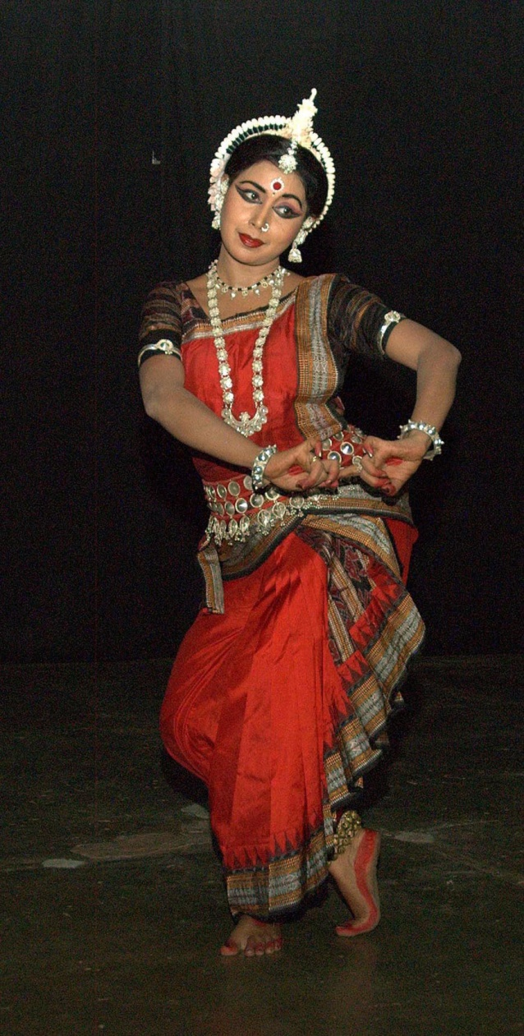

GURU ARUNA MOHANTY
Dynamism, charisma and astounding talent makes Guru Smt. Aruna Mohanty one of the finest Odissi Dancers in the world today. She was trained under the guidance of late Guru Padmashree Gangadhar Pradhan and runs the Orissa Dance Academy school that he founded. An eloquent dancer and performer, she is known for her innovative choreography and interpretation. She excels in the abhinaya aspect of Odissi. She has received many awards and accolades for her contribution to the arts. They include the Mahari Award, Sanjukta Panigrahi Memorial National Award, Fellowship by Ministry of HRD, Government of India, and the prestigious Sangeet Natak Akademi Puraskar Award in 2010.
Some of the items in her repertoire include the dance ballet ‘Shrusti O Pralaya’, ‘Varsha-Abhisara’, ‘Sravana Kumara’, ‘Kharavela’ , ‘Jatra Baramasi’, ‘Gatha Odishi’, ‘Krupa Nidhaana’, ‘Swargadapi Gariyasi’, ‘ Arjuna Dui Adhyaya’, ‘Pratinayaka’, ‘Krishna Shranam’, ‘Geeta Govinda’ and ‘Khamaj Pallavi’. She has traveled all over the globe to present solo and group presentations in addition to workshops and lecture demonstrations. She served as a member of Central Sangeet Natak Akademi, New Delhi and currently serves as the vice president of the Odisha Sangeet Natak Akademi.

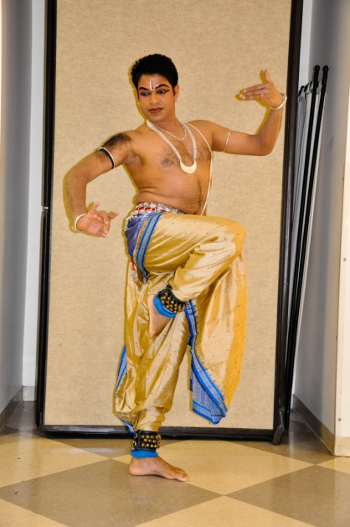 SRI YUDHISTIR NAYAK
Belonging to a rare breed of Odissi dancers, Yudhisthir Nayak is trained in both Odissi Vocal and Odissi Mardal. Initiated to Gotipua dance at the tender age of seven, subsequently he took up Odissi dance under the tutelage of Guru Gangadhar Pradhan at Orissa Dance Academy. A master of varied nuances of Odissi dance, he is a recipient of Senior National Scholarship and has carved a niche for himself as a resident teacher at Center for World Music, Sandiego. As a soloist, he has performed in the prestigious ‘Dhauli Mahotsav’ and ‘Udayaraga’ organized by ODA. A rare combination of being a good performer, a soloist and an excellent teacher, Yudhisthir has extensively performed in India and abroad. He has also traveled abroad to participate in the 14th International Festival of Dance & Music, Thailand and perform in major cities of USA.
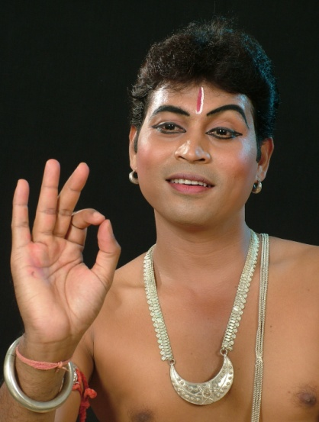 PABITRA KUMAR PRADHAN
Pabitra Kumar Pradhan started receiving his training at Orissa Dance Academy at the age of fifteen. Bestowed with a captivating stage presence, Pabitra has featured in major festivals and has performed widely at places like Raipur, New Delhi, Bhopal, Ahmedabad, Guwahati Tanjavur, Pondicherry and Bangalore. Being a talented performer & excellent instructor he is also bestowed with the unique talent of choreographic new items. He has been awarded the Senior national Scholarship from the Ministry of HRD, Govt. of India. As a soloist, he has performed in the prestigious ‘Dhauli Mahotsav’ and ‘Nritya Pratibha’ organized by Sangeet Natak Akademi. Sponsored to the 20th spring Friendship Art Festival, Pyongyang, North Korea, the 14th International Festival of Dance & Music by ICCR, he has also performed in the major cities of USA & UK. He has also performed in 2nd and 3rd International Odissi festival, Glasgow Festival and Shanghai Trade Fair.He is the recipient of “Sanjukta Pratibha Samman” & auditioned artiste of Doordarshan.
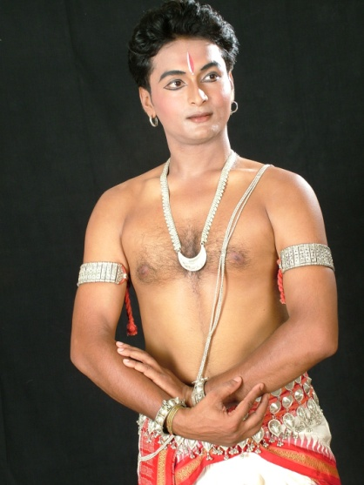 BISWAJIT DAS :
Biswajit started Odissi dance training at the Orissa Dance Academy (ODA), Bhubaneswar at the age of 9. He has been working relentlessly under the watchful eyes of Guru Smt. Aruna Mohanty. Biswajit continues to be groomed at ODA as a versatile solo artist and as an energetic member of the repertory group. He has been awarded the Senior National Scholarship by the Ministry of Human Resource Development. He has performed widely inside the country and abroad in USA, China, Canada & Mauritius.

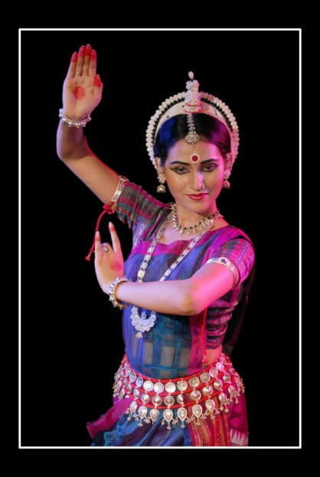 Arupa Gayatri Panda:
Arupa is a rising star in the field of Odissi dance. Having trained at ODA for the past nine years under the guidance of Madhusmita Mohanty, Arupa began performing professionally at a young age, joining the prestigious Nrityagram troup in Bangalore for their U.S. tour at the age of 17. Arupa has received a number of awards and honors including the prestigious Sanjukta Panigrahi Scholarship in 2002 and the Senior National Scholarship from Ministry of HRD, Govt. of India. Arupa is continuing her training as a group and solo artist, joining senior dancers at ODA in performances all over the globe. Recently she has participated in the 14th International Festival of Dance & Music, Thailand, “Festival of Days of India in Germany" and also performed in Cambodia, Vietnam and Myanmar to give cultural performances in connection with the Asian Car Rally sponsored by ICCR.
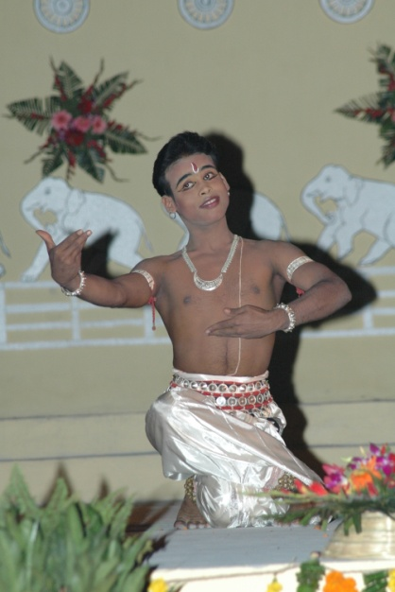 PRASHANT KUMAR BEHERA
Initiated into the art of Gotipua dance Prashant later joined Orissa Dance Academy where he received formal training in Odissi dance. Recipient of Senior National Scholarship from Deptt. of HRD, . he is presently doing his Master degree in Dance at the Utkal University of Culture, Bhubaneswar. He has performed widely inside the country and abroad. Recently he has participated and performed in Cambodia,Vietnam and Myanmar to give cultural performances in connection with the Asian Car Rally sponsored by ICCR.
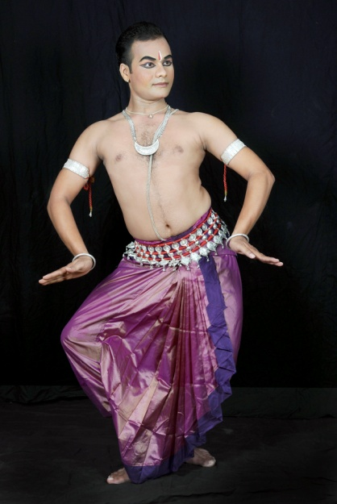 RAJESH KUMAR PALAI
Rajesh is a young and promising Odissi dancers of present generation. He was trained as a gotipua dancer at Chandrasekhar Gotipua Kalasanshada in Dimirisena, Puri. He received his formal training in Odissi at Orissa Dance Academy, Bhubaneswar under the direct supervision of Guru Gangadhar Pradhan and Guru Aruna Mohanty. Currently working as student-performer-teacher at ODA. He has widely performed at different places inside the country with the performing unit of ODA. Recently he has participated in the 14th International Festival of Dance & Music, Thailand.
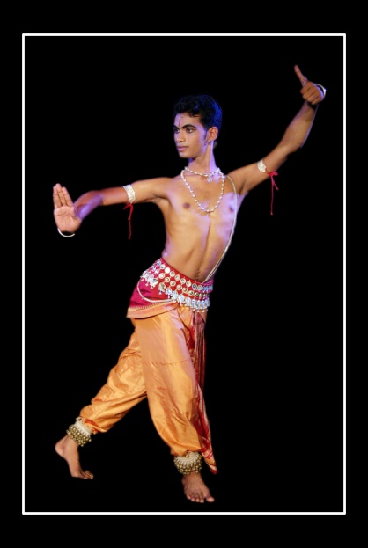 RUDRA PRASAD SWAIN
Initiated into Gotipua Dance at a tender age of 5, Rudra Prasad Swain has proved himself to be a child prodigy. Later he trained himself to be a fine young Odissi dancer under the direct supervision of senior gurus of Orissa Dance Academy. Currently he is pursuing his Masters degree in Music at Utkal University of Culture, Bhubaneswar. Recently he has participated in the 14th International Festival of Dance & Music, Thailand, Festival of "Days of India in Germany" sponsored by ICCR.
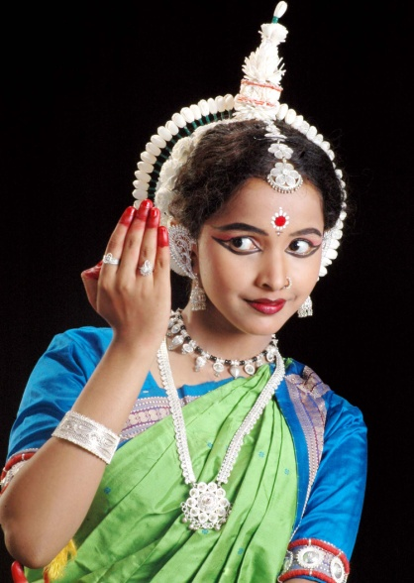 PUJA JENA
Puja Jena started learning Odissi Dance at Orissa Dance Academy from a very tender age of four. She has been a performing artiste for the last seven years, participating in various prestigious podiums in India and abroad. At the age of fifteen she participated in the Glasgow Dance Festival as the youngest member in the group headed by Guru Gangadhar Pradhan. She is the recipient of Junior National Scholarship awarded by the Ministry of HRD, Govt. of India. She is one of the budding talents trained under the direct supervision of Guru Smt. Aruna Mohanty and other senior teachers of Orissa Dance Academy. She is currently pursuing a degree in Bachelors in Commerce.
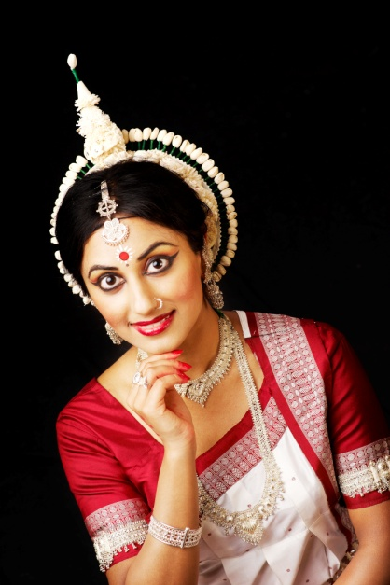 SHIPRA AVANTICA MEHROTRA
Indian-American Shipra Avantica Mehrotra is recognized today as a rising exponent and instructor of Odissi dance. The New York Times described her performance at the 2010 Erasing Borders dance festival as “wholly poetic” and “the truest revelation of dance itself.” Initially trained by Dr. Chitra Krishnamurti at the Nrityalaya School of Odissi Dance, Shipra went on to receive advanced training at the Orissa Dance Academy from the late Padmashree Guru Gangadhar Pradhan and Smt Aruna Mohanty. With technical virtuosity and evocative abhinaya, Shipra has performed across the United States and India, most recently at the 2012 Asia Society Texas Center First Look Festival, the 2012 International Odissi Festival, and the 2011 Orissa Society of the Americas National Convention. Finally, Shipra is the founder and artistic director of Avantica Academy of Odissi Dance, based in Houston, TX.
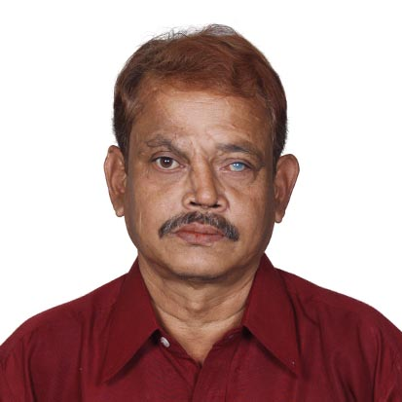 JAYDEV DAS – Light Technician
Jaydev Das is acclaimed to be the one of best Odissi Dance light designer in India today. His outstanding sense of the Odissi Choreography; the understanding of the Odissi Dance postures and movements, recognition of the thematic expressions of the Abhinaya is second to none. He designs the total lighting requirements of the performance and meets the dancer’s need to make the performances more glamorous. Jaydev Das was the first light/sound designer to accompany Padmabibhushan Guru Kelu Charan Mahapatra’s tours to United States and Canada in 1996, 2000 and 2003. Guruji is the first one, who recognized the importance of a sound/light designer for a performance and how it highlights the performances. Jaydev has been acknowledged by the Dept. of Culture, Govt. of Odisha as their prime sound/light consultant and designer for all their festival and programmes. He has been closely associated with all the programmes performed by Srjan, Orissa Dance Academy, Kala Vikash Kendra etc. IPAP has been privileged to avail Jaydev as the Chief Sound/Light designer for the last four International Odissi Dance Festivals in 2000, 2003 (Washington DC) 2006 and 2011 (Bhubaneswar, Odisha, India)

ORISSA DANCE ACADEMY
Founded in 1975 by Late Guru Gangadhar Pradhan, Orissa Dance Academy is an institution engaged in teaching and promoting Odissi dance, music and related art forms. It has played a prominent role in popularizing and propagating Odissi in India and abroad. Its exemplary training method and skilled teaching staff have produced young solo dancers and innovative group compositions. Odissi dance has been predominantly performed by female danseuse. However, this institution has made it a priority to produce some of the most talented and versatile male dancers in the field of Odissi. ODA’s repertory group has enthralled audiences in the U.S., Canada, U.K, South America, France, Holland, Japan, China, Indonesia, Malaysia, Korea, Germany and other countries of Asia and Europe. Their faculties have taught all across India and abroad, including the United States.
The organization is led by Aruna Mohanty, the principal artist in today’s program.

